Crystals so flexible that they can be tied into knots

Jack K. Clegg
School of Chemistry and Molecular Biosciences, The University of Queensland, Brisbane St Lucia, QLD, Australia, 4072. E-mail: j.clegg@uq.edu.au
A crystal is normally thought of as a homogenous solid formed by a periodically repeating, three-dimensional pattern of atoms, ions, or molecules. This regular arrangement of molecules in a single crystal leads to many useful characteristics (in addition to diffraction!) including unique optical and electrical properties, however, molecular crystals are not typically mechanically robust, particularly compared to crystals of network solids like diamond. Upon the application of stress or strain, these crystals generally irreversibly deform, crack or break resulting in the loss of single crystallinity.
We have recently discovered a class of crystalline compounds that display the intriguing property of elastic flexibility – that is they are capable of reversibly bending without deforming, cracking or losing crystallinity. A number of these crystals are flexible enough to be tied into a knot! (Figure 1). We have developed a unique approach to determine the atomic-scale mechanism that allows the bending to occur which employs mapping changes in crystal structure using micro-focused synchrotron radiation. We have applied this technique to understand the deformation in both elastically and plastically flexible crystals.
Most recently we have used this new insight to further develop our understanding of the molecular origins of elasticity, and allowed us to locate the origin of the restoring force in molecular crystals for the first time. Such
outcomes open the door for the design of new and elastically flexible crystals for advanced technologies.

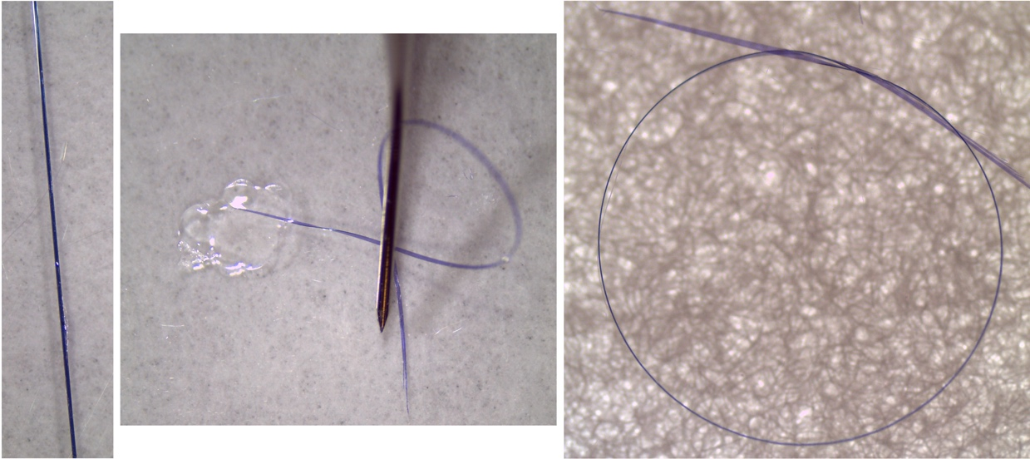
Figure 1: A crystal of [Cu(acac)₂] showing elastic flexibility.

References
A. Worthy, A. Grosjean, M. Pfrunder, Y. Xu, C. Yan, G. Edwards, J. K. Clegg and J. C. McMurtrie, “Atomic Resolution of Structural Changes in Elastic Crystals of Copper(II) acetylacetonate”, Nature Chemistry, 2018, 65-69.
S. Bhandary, A. J. Thompson, J. C. McMurtrie, J. K. Clegg, P. Ghosh, S. R. N. K. Mangalampalli, S. Takamizawa, and D. Chopra, “The mechanism of bending in a plastically flexible crystal.” Chem. Commun., 2020, 12841-12844.

A. J. Thompson, A. I. Chamorro Orué, A. J. Nair, J. R. Price, J. McMurtrie and J. K. Clegg, Chem. Soc. Rev., 2021, 11725-11740.

A. J. Thompson, B. S. K. Chong, E. P. Kenny, J. D. Evans, J. A. Powell, M. A. Spackman, J. C. McMurtrie, B. J. Powell and J. K. Clegg, Nat. Mater., 2025, 24, 356-360.

