Ultra-SLP Speakers in Alphabetic Order by Last Name
Suzanne Boyce, Ph.D. CCC-SLP
Speaker Bio:
Suzanne Boyce is a speech language pathologist with degrees in Linguistics and Speech-Language Pathology, along with postdoctoral training in Speech Engineering. She has had continuous research support from the NIH since 1995 and has taught speech science at the graduate and PhD level since 1997 while mentoring projects on swallowing, voice, motor speech, craniofacial, and speech sound disorders. Recent projects focus on ultrasound biofeedback therapy and machine learning methods to track articulation from acoustics.
Disclosures:
Suzanne Boyce is an employee of the University of Cincinnati. She has several NIH and NSF research grants and is on the Executive Council of the Acoustical Society of America.
Picture:
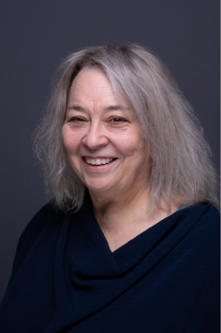
Karen Brackenbury, M.A. CCC-SLP
Speaker Bio:
Karen L. Brackenbury, M.A., CCC-SLP, is an Assistant Clinical Professor in the Department of Communication Sciences and Disorders at Bowling Green State University. She brings more than 30 years of clinical and supervisory experience in speech-language pathology across university, medical, inpatient, and outpatient settings. Her professional interests include the integration of ultrasound technology into the assessment and treatment of speech sound disorders, while mentoring graduate clinicians in evidence-based practice and clinical decision-making.
Disclosures:
Karen Brackenbury was offered a waived registration fee to speak at the Ultra-SLP conference, and has no other relevant relationships to disclose.
Picture:
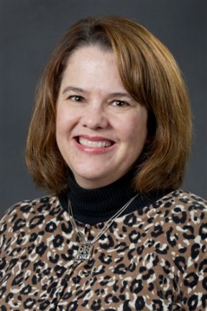

Kori Clements, SLPD, CCC-SLP
Speaker Bio:
Kori Clements, SLPD, CCC-SLP, is an instructor and clinical educator in speech-language pathology and a PhD student in Health Professions Education. Her work focuses on practical, evidence-informed teaching and supervision strategies, with interests in speech sound disorders, clinical education, and technology-supported learning. She has presented innovative instructional approaches in speech-language pathology education and is committed to helping clinicians translate reflective, research-informed practices into everyday clinical work.
Disclosures:
I received a waived registration fee to speak at the Ultra-SLP conference.
I receive a salary through West Texas A&M University, which supports Ultrasound Research funding.
Picture:
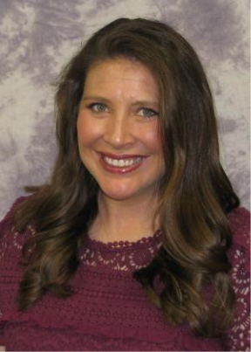

Jianwen Crump, Ed.D CCC-SLP
Speaker Bio:
Dr. Jianwen Crump is an Assistant Professor and a clinical supervisor of the Mississippi University for Women Speech and Hearing Center. Prior to joining the faculty at Mississippi University for Women, Professor Crump worked in an array of settings, including: public schools, private practice, early intervention, long-term acute care, and skilled rehab. She graduated from Mississippi University for Women in 2012 with a BS in Speech Language Pathology and earned her MA from Louisiana Tech in 2014. She completed doctoral studies at William Carey University resulting in an EdD in Educational Leadership w/ concentration in Assessment and Curriculum in 2019. Dr. Crump specializes in the rehabilitation of speech, language/cognition, literacy acquisition, autism and fluency in clients 0-99+. She has particular interest in prevention of communication and disorders associated with deficient acquaintance to quality language exposure and literacy habilitation. She has a strong interest in the use of ultrasound visual biofeedback use in articulation therapy and helping patients to accomplish their personal goals and to optimize their quality of life. Dr. Crump’s academic goals include improving communication through clinical research. She is involved in the education of future speech pathologists, early childhood professionals and international families. She regularly lectures on literacy, speech, language and cognition locally and internationally. She collaborates with Faith & Power Ministries to provide health education to underserved and disadvantaged populations across multiple regions of Nigeria (Africa). She teaches graduate level courses at Mississippi University for Women and is a member the American Speech Language Hearing Association.
Disclosures:
Dr. Jianwen Crump receives a salary from Mississippi University for Women to facilitate the Ultrasound Lab and Research. Dr. Jianwen Crump receives an honorarium from FLASHA and Albizu University for introductory courses surrounding the implementation of ultrasound biofeedback. She is a member of the Conference Committee for the ULTRA-SLP Conference, Vice chair of the Funding Panel Committee, and Chair of the Supervision Panel Committee. She was offered a waived registration fee to speak at the Ultra-SLP conference.
Picture:
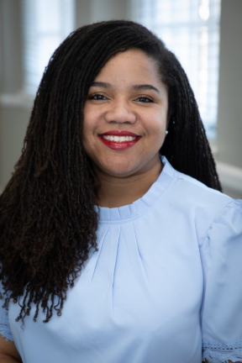

Sarah Dugan, Ph.D. CCC-SLP
Speaker Bio:
Sarah Dugan is a clinical researcher and speech-language pathologist at Cincinnati Children’s Hospital. She has used ultrasound biofeedback for treating speech sound disorders since 2011. Her experimental research focuses on motor response to different types of visual feedback and gamification, as well as characterizing the auditory perceptual response of American English rhotics in different listeners. She uses implementation science methodology to research the experiences and training needs of SLPs who have used ultrasound for biofeedback during speech sound therapy. Along with working clinically, she trains SLPs and students in ultrasound biofeedback for speech disorders and is currently researching ultrasound implementation and apraxia treatment in pediatric outpatient settings. Sarah Dugan has a PhD in Speech-Language Pathology from the University of Cincinnati (UC), an M.A. in Speech-Language Pathology from UC, an M.A. in Linguistics from York University (Canada), an MA in English from West Virginia University, and a BA in Linguistics from University of Toronto (Canada).
Disclosures:
Sarah Dugan received a waived registration fee for speaking at this conference. She receives a salary from the Cincinnati Children’s Hospital.
Picture:
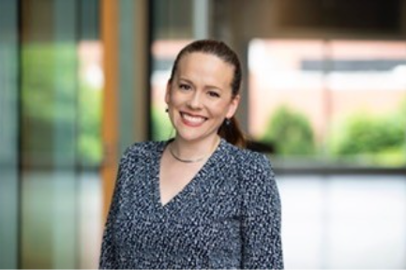

Amanda Eads, Ph.D.
Speaker Bio:
Amanda is an NIH NIDCD F31 predoctoral fellow who recently defended her dissertation in the NYU department of Communicative Sciences and Disorders. Her clinical research focuses on children acquiring the American English ‘r’ (/ɹ/) sound within biofeedback speech therapy contexts. Her dissertation “Enhancing AI-based Speech therapy through Acoustic and Articulatory feedback” links the acoustic signal for American English ‘r’ to ultrasound based articulatory information with the goal of recognizing a child’s perceptual accuracy and tongue shape position. The aim of this work is to provide children with personalized articulatory feedback when acquiring the ‘r’ sound as well as providing clinicians articulatory insight and targeted cueing strategies.
Disclosures:
Amanda Eads received a waived registration fee for speaking at this conference and receives compensation from the NIH NIDCD through an F31 fellowship which uses ultrasound technology to enhancing AI-based speech therapy for American English /ɹ/ through acoustic and articulatory feedback.
Picture:
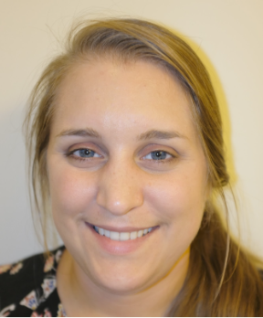

Elizabeth Farmer, M.S. CCC-SLP
Speaker Bio:
Elizabeth is a speech-language pathologist with ten years of experience working in the public schools and three years of experience as a consultant/researcher/graduate student instructor working on ultrasound biofeedback to treat /r/ at the University of Cincinnati. She is especially interested in /r/, childhood apraxia of speech, neurodiversity-affirming therapy, and translational research. She enjoys spending time with friends, family, and her dog Sky, creative writing, reading, playing soccer, volunteering, and west coast swing dancing.
Disclosures:
Financial Relationships:
- Consultant - clinical researcher (Summer 2024)
- Received a grant for an ultrasound wand that plugs into an iPad to do research in the school setting (2024-2025 school year)
- Adjunct Instructor - supervisor in /r/ ultrasound biofeedback clinic (Summer 2025)
- Received a stipend to attend ASHA 2025 in order to present on our work there from Dr. Boyce's lab in two presentations: (1) Community Perspectives on Using Ultrasound for Speech Therapy in Appalachian Schools and (2) Using Gamified Ultrasound Biofeedback for Speech Sound Disorders
- Was offered a waived registration fee to speak at the Ultra-SLP conference.
Nonfinancial Relationships:
- University of Cincinnati Volunteer (Summer 2023)
- UC SLP Graduate Program Advisory Board Member (2023-present)
- Using Ultrasound for Speech Therapy - Presentation with Dr. Sarah Dugan for the Southern Ohio Educational Service Center (Fall 2024)
Picture:
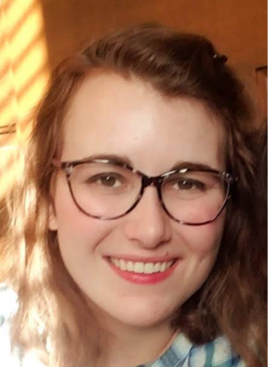

Kelly Farquharson, Ph.D. CCC-SLP
Speaker Bio:
Kelly Farquharson is a professor at Florida State University. She directs the Children’s Literacy and Speech Sound (CLaSS) lab, which has a mission to help children with speech and language impairments achieve classroom success. Using implementation science, she also works to support school-based SLPs in the selection and sustainment of evidence-based practices. Find her on Instagram @classlab_Kelly, which has a popular weekly series called Phonetics Fridays.
Disclosures:
Kelly Farquharson receives a salary from Florida State University. She is the owner of Literacy Speech, LLC. She is a member of the American Speech Language Hearing Association. She was offered a waived registration fee to speak at the Ultra-SLP conference.
Picture:
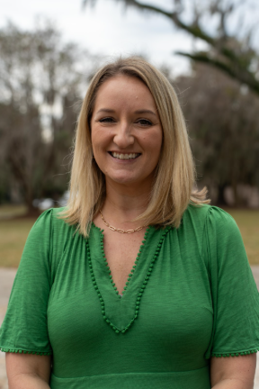

Stacey Gerding, M.S. CCC-SLP
Speaker Bio:
Stacey is a licensed speech-language pathologist and clinical supervisor for UC's Speech and Hearing Clinic. She provides clinical services related to stuttering / fluency, accent modification, language disorders / delay, social skills intervention, ultrasound biofeedback for /r/, and speech sound disorders across the lifespan. Stacey also serves as Assistant Director of Clincial Education. She has a Master of Science in Speech-Language of Pathology from Purdue University.
Disclosures:
Stacey receives a salary from University of Cincinnati. She received a complimentary registration to the conference.
Picture:
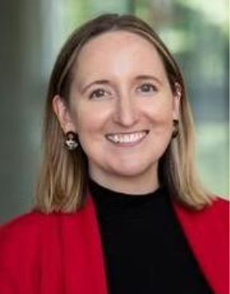

Maria Hardesty, M.S. CCC-SLP
Speaker Bio:
Maria Hardesty, MS, CCC-SLP is a research Speech-Language Pathologist and Clinical Research Coordinator working in the Dysphagia Rehabilitation Lab at the University of Cincinnati. She is involved with data collection and data management of various lab studies including ongoing research with bedside ultrasound applications for swallowing assessment and real-time biofeedback. Maria is passionate about clinically applicable research and has interests in improving accessible, research-based dysphagia diagnostic and treatment tools.
Disclosures:
Maria Hardesty was offered complementary registration to this conference.
Financial Disclosures: Hourly Part-Time Employee of UC
Non-Financial: None
Picture:
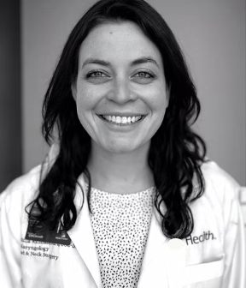

Hedieh Hashemi Hosseinabad, Ph.D. CCC-SLP
Speaker Bio:
Dr. Hashemi Hosseinabad is an assistant professor in the Department of Audiology and Speech Language Pathology. Dr. Hashemi Hosseinabad’s research program has two active lines of research that focus on advancing the understanding of the principal characteristics of speech in individuals with cleft palate and craniofacial anomalies. The first line of work focuses on understanding the factors affecting the intelligibility measurement of VPI speech. The second research program takes a diverse approach to studying persistent speech disorders in children with cleft palate, emphasizing persistent errors caused by co-occurring conditions like syndromic conditions and other pervasive developmental disorders. Dr. Hashemi Hosseinabad combines complementary measures such as acoustic-based and visual tools to assess/treat speech disorders in individuals with cleft palate.
Dr. Hashemi Hosseinabad received her Ph.D. in speech and hearing science, at the University of Cincinnati. She also holds a Masters in speech language pathology from Tehran University of Medical Sciences and a Bachelor of Science from Isfahan University of Medical Sciences. Dr. Hashemi H is an American Speech-Language-Hearing Association certified speech-language pathologist. She has over 14 years of experience working with children with cleft palate and VPI.
Disclosures:
Financial Disclosure: Hedieh Hashemi Hosseinabad is a full-time assistant professor and receives a salary from the University of North Texas. She also received a registration waiver for this presentation from the Ultra-SLP Conference. Non-financial Disclosure: Dr. Hashemi serves on the Editorial Board of the ASHA Perspectives and the Cleft Palate and Craniofacial Journal.
Picture:
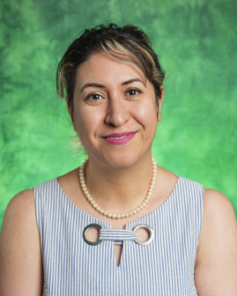

Elaine Hitchcock, Ph.D. CCC-SLP
Speaker Bio:
Dr. Elaine Hitchcock, professor and chair in Communication Sciences and Disorders at Montclair State University, leads the Clinical Biofeedback Lab.
She researches speech sound development/treatment, examining subgroups of children with SSD and RSSD, including those with distinct speech perception profiles or motor speech characteristics, and evaluating the efficacy of treatment. Her recent grant-funded work explores the interaction between speech perception and production and investigates optimizing treatment dosage, refining outcome measures, and developing innovative interventions.
Disclosures:
- Dr. Hitchcock’s Clinical Biofeedback Lab is partly supported by NIH R15DC019775 (Hitchcock) and NIH R01DC017476 (McAllister).
- Dr. Hitchcock served as a reviewer for the 2026 ASHA Topic Committee for Speech Sound Disorders in Normal Hearing Children.
- Dr. Hitchcock is a salaried professor at Montclair State University.
- Dr. Hitchcock was offered a waived registration fee to speak at the Ultra-SLP conference.
Picture:
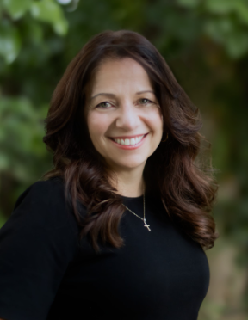

Mary Huston, Ph.D. CCC-SLP
Speaker Bio:
Mary Huston, PhD, MS, CCC-SLP, is an Associate Professor and Department Chair/Program Director at Minot State University. She collaborates internationally with speech-language pathologists through professional platforms and her blog, www.speechadventures.com. Dr. Huston has authored five iPad applications for speech-language therapy published by Smarty Ears LLC and currently serves as President of the North Dakota Speech-Language-Hearing Association. She previously practiced as a school-based speech-language pathologist.
Disclosures:
I am employed by Minot State University and received funding for the ultrasound through activities related to the university. I was offered a waived registration fee to speak at the Ultra-SLP conference,
I have no non-financial disclosures.
Picture:
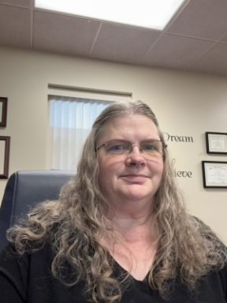

Brittany Krekeler, Ph.D. CCC-SLP
Speaker Bio:
Brittany Nicole Krekeler, PhD, CCC-SLP, is an Associate Professor in the Department of Otolaryngology–Head and Neck Surgery at the University of Cincinnati College of Medicine, with secondary appointments in Communication Sciences and Disorders and in Neurology and Rehabilitation Medicine. She directs the Dysphagia Rehabilitation Lab, the institution’s first multidisciplinary swallowing research program, with the central mission of developing sustainable, effective approaches to improve outcomes for patients with dysphagia. Her NIH-funded translational research integrates advanced imaging, exercise physiology, neurorecovery science, and bioengineering to better detect, characterize, and treat swallowing disorders, particularly in stroke and head and neck cancer populations. Through cross-disciplinary collaborations with otolaryngology, neurology, biomedical engineering, and allied health, her work advances novel rehabilitation strategies, including lingual endurance training and neuroimaging-informed recovery models, and pioneering bedside ultrasound applications for swallow assessment and real-time biofeedback. Grounded in active clinical practice, her program is focused on generating clinically meaningful, implementable solutions that redefine post-acute dysphagia monitoring and rehabilitation while training the next generation of clinicians and clinician-scientists.
Disclosures:
Financial Disclosures: Salary UC/UCP, was offered a waived registration fee to speak at the Ultra-SLP conference; Non-Financial: None
Picture:
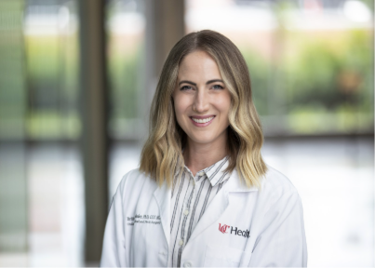

Megan Leece, M.A. CCC-SLP
Speaker Bio:
Megan Leece, MA, CCC-SLP is a speech-language pathologist with over 25 years of experience treating children with speech sound disorders. Formerly of the Speech Production Lab at Syracuse University, she has spent 10 of those years specializing in technology-aided intervention with a focus on ultrasound biofeedback. She has trained private practices and clinics in implementing ultrasound-based treatment approaches.
Disclosures:
Megan has worked as an independent consultant training private practices and clinics in using ultrasound to treat speech sound disorders. Nonfinancial disclosures: ASHA member, NYSSLA member. Megan was offered a waived registration fee to speak at the Ultra-SLP conference.
Picture:
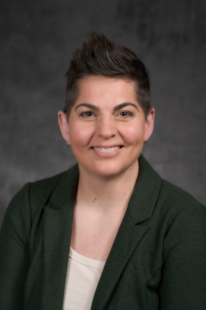

Sarah Li, Ph.D.
Speaker Bio:
Sarah Li received her PhD in Biomedical Engineering from the University of Cincinnati. Her dissertation research focused on expanding the interpretation of tongue ultrasound images during speech production. She is particularly interested in improvements to the accessibility of ultrasound imaging, noninvasive ultrasound technologies, and in leveraging speech for healthcare (e.g., speech biomarkers, speech therapy).
Disclosures:
Sarah Li's data analysis for this presentation was supported previously by a graduate research stipend from the University of Cincinnati through NIH funding. They currently serve as a volunteer researcher at the University of Cincinnati; was offered a waived registration fee to speak at the Ultra-SLP conference.
Picture:
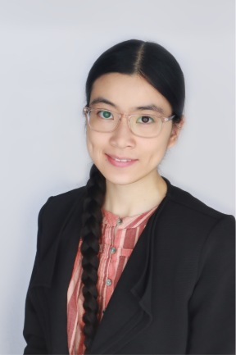

Jon Preston, Ph.D. CCC-SLP
Speaker Bio:
Dr. Jonathan Preston is a speech-language pathologist and clinical researcher focusing on speech sound disorders. He received his PhD from Syracuse University in 2008 and completed postdoctoral training at Haskins Laboratories, an affiliate of Yale University. He is a Professor in the Communication Sciences and Disorders Department at Syracuse University and is a Fellow of the American Speech-Language-Hearing Association. His research focuses on neurolinguistically-motivated and evidence-based treatments for speech sound disorders. He is currently involved in multiple clinical trials studying motor-based treatments, biofeedback treatments, perceptual treatments, and service delivery models for children with persisting speech sound errors and childhood apraxia of speech. He is also co-founder of SpeechLink Incorporated, which distributes software for speech sound disorder treatment.
Disclosures:
- Salary received from Syracuse University.
- Grant funding received from the National Institutes of Health and Apraxia Kids for biofeedback research
- Co-founder of SpeechLink, a company working toward commercialization of Speech Motor Chaining and Artificial Intelligence practice paradigms for speech sound disorders
- Offered a waived registration fee to speak at the Ultra-SLP conference
Picture:
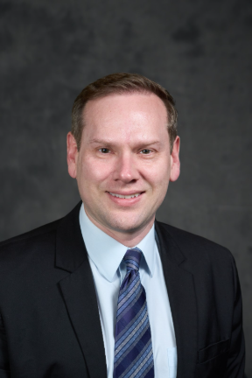

Ahmed Rivera Campos, Ph.D. CCC-SLP
Speaker Bio:
Ahmed Rivera Campos is a Spanish-English bilingual speech-language pathologist. He completed his master’s degree in Speech Language Pathology at Universidad Ana G. Mendez and his Ph.D. at the University of Cincinnati. He currently works as an associate professor at Texas Christian University where he conducts research related to ultrasound visual biofeedback and teaches at the undergraduate and graduate levels.
Disclosures:
Dr. Ahmed Rivera Campos is a salaried faculty member at Texas Christian University, where he conducts research related to ultrasound visual biofeedback for speech sound production. He receives no financial support, honorarium, travel reimbursement, or other compensation from Ultra-SLP for this presentation. He was offered a waived registration fee to speak at the Ultra-SLP conference. He has no other relevant relationships to disclose.
Picture:

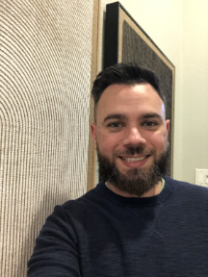

Caroline Spencer, Ph.D.
Speaker Bio:
My research focuses on the interactions between the brain and behavior to better understand mechanisms of speech production in individuals across the lifespan. I am interested in neurodevelopmental and neurodegenerative speech production disorders, including speech sound disorder, autism spectrum disorder, Parkinson’s disease, and ataxia. My research aims to improve understanding of how brain function, behavior, and quality of life interact in communication disorders.
Disclosures:
Caroline Spencer receives a salary from Indiana University. Work presented in this talk was supported by National Institute on Deafness and Other Communication Disorders Award DC013668 (D. Whalen, PI, S. Boyce, mPI) and DC017654 (C. Spencer, PI), as well as the Indiana University Faculty Research Support Program Seed Grant (co-PIs C. Spencer and A. Moussa-Tooks). She was offered a waived registration fee to speak at the Ultra-SLP conference.
Picture:
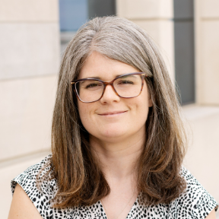

Jen Vannest, Ph.D. CCC-SLP
Speaker Bio:
Jennifer Vannest is Professor of Communication Sciences and Disorders at the University of Cincinnati and a Speech-Language Pathologist at Cincinnati Children’s Hospital. Her research is focused on the neural bases of language and neuroplasticity associated with language development and disorders across the lifespan, including effects of early life adversity on early language development, brain networks underlying speech and language skills in children, and the neural basis of recovery from aphasia.
Disclosures:
Dr. Vannest is an employee of the University of Cincinnati and Cincinnati Children’s Hospital. She receives research funding from the National Institutes of Health. She was offered a waived registration fee to speak at the Ultra-SLP conference.
Picture:
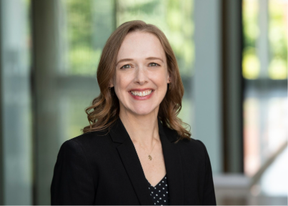

Peter Wagreich, M.A. CCC-SLP
Speaker Bio:
Peter Wagreich is a speech-language pathologist at Cincinnati Children's Hospital Medical Center. He earned an undergraduate degree in Linguistics from University of California Santa Cruz and a master's degree in Speech-Language Pathology from Northwestern University. His clinical experiences and interests include pediatric voice, cleft palate and resonance, and the use of ultrasound visual biofeedback in speech therapy. He is an active clinician in the Center for Pediatric Voice Disorders and Velopharyngeal Insufficiency Clinic.
Disclosures:
Peter Wagreich is a salaried employee of Cincinnati Children's Hospital Medical Center. He is not receiving a speaking fee for this event. He was offered a waived registration fee to speak at the Ultra-SLP conference.
Picture:
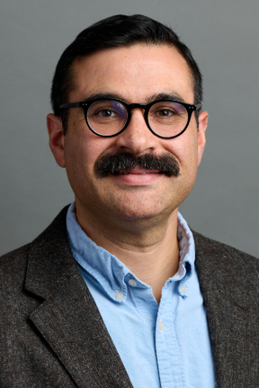

Nadine Whiteman, M.A. CCC-SLP
Speaker Bio:
Nadine Ocock Whiteman, M.A., CCC-SLP is a licensed and certified Speech-Language Pathologist. She began employment in 1996 at OSU as a Clinical Preceptor for graduate students at the Ohio State University Speech-Language-Hearing Clinic (OSU SLHC). Prior to OSU, her employment included acute care hospitals as well as non-profit community clinics. She has over 30 years of experience serving individuals of all ages with a variety of communication disorders. Areas of interest include articulation and phonology intervention; literacy intervention; and corporate speech and accent management instruction. She initiated and conducts the Clearly Communicating program at the OSU SLHC.
Disclosures:
Nadine Whiteman has no relevant relationships to disclose. She was offered a waived registration fee to speak at the Ultra-SLP conference.
Picture:

